PO creation

Upon PR Approval for PR that are Std Item: Y;

The PR will automatically go through all the stages for Create PO and PO will be emailed out to supplier.

The following steps will proceed automatically without requiring any action from Procurement staff.

1) No need for Procurement staff to click on Create PO

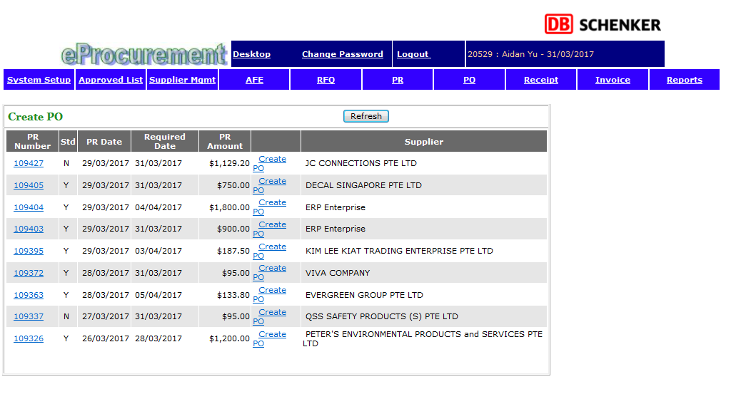

2) No need for Procurement staff to click on “PO Admin”

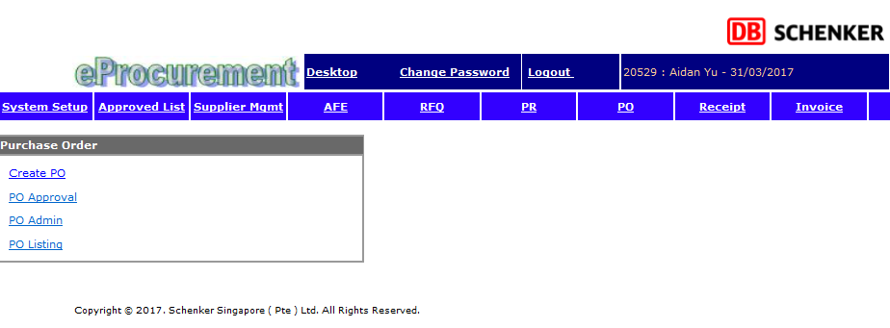

3) No need for Procurement staff to click on Generate

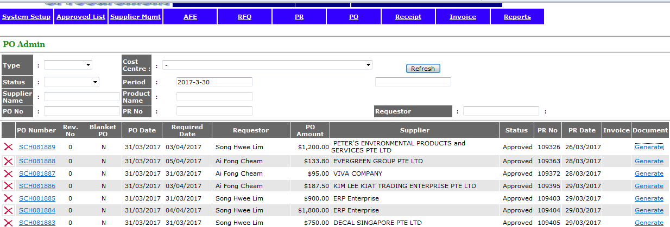

4) No need for Procurement staff to click click the ok

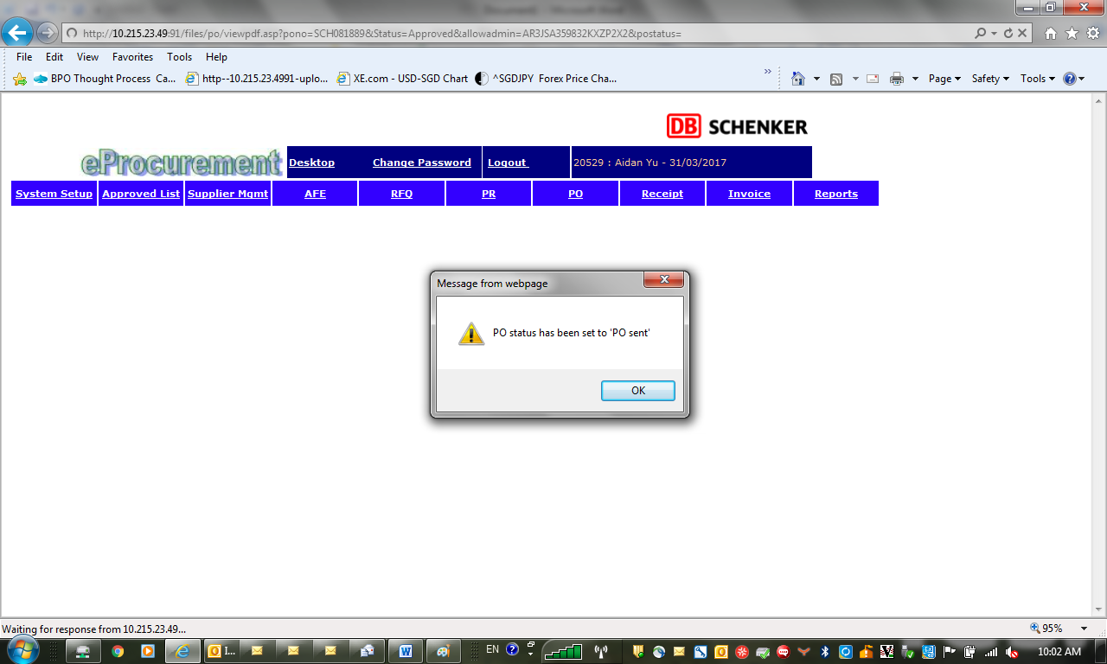

4) No need for Procurement staff to click on sent

